PHANI KUMAR ALAKAM

+91 812-125-1534

[alakamphani599@gmail.com](mailto:alakamphani599@gmail.com) A-294,Vambay Colony Vijayawada-520015,Andhra

Pradesh ,India.

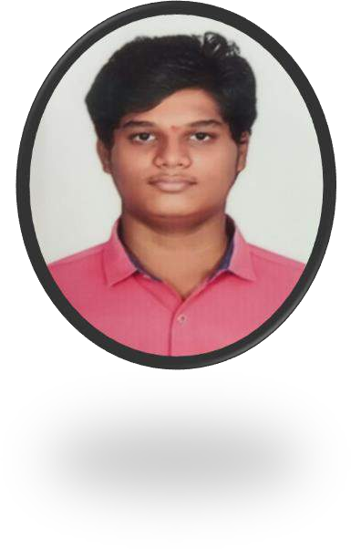

# Objective

Dedicated and driven B.Tech student with a strong academic background and a passion for technology seeking opportunities to apply my knowledge and skills to make a meaningful contribution in [industry/field]. Eager to learn, adapt, and excel in a professional setting.

# SKILLS

* HTML
* CSS
* JAVASCRIPT

(beginner)

* DBMS
* SQL(Basics)
* DATA STUCTURES

& ALGORITMS(Basics

* PYTHON(Advance)

# EDUCATION

* Under Graduation 11/2023-Pursuring

**B.Tech,**AMRITA SAI INSTITUTE OF SCIENCE & TECHNOLOGY

* 06-/2019 -07/ 2021

**INRERMEDIATE**,SARADA JUNIOR COLLEGE

Percentage : 86%

* 10/2007-2019

**SCHOOLING**,FUTURE PATH E.M HIGH SCHOO

Percentage:85%

# LANGUAGES KNOWN

* ENGLISH • HINDI • TELUGU

# PERSONAL DETAILS :

First Name :PHANI

Middle Name :KUMAR

Last Name :ALAKAM

Father Name :ALAKAM MAHESH

Mother Name :ALAKAM SIVA KUMARI

Siblings :1(Brother)

Name :ALAKAM ESWAR TARAK

Education :Mentioned above in detailed

Goals : To get a job in multinational company

Hobbies :playing games,watching movies

# SIGNATURE

ALAKAM PHANI KUMAR